https://www.astrj.com/ storna czasopisma
Zalecenia:
The text body should not be formatted, for example, splitting in columns, adding headers and footers is forbidden.
Nomenclature or abbreviations list is not needed – all explanations should be placed in the text.
Recommendation section is not allowed.
The Volume of the Article
The volume of the article (including tables and illustrations) should not exceed 20 pages of A4 format (included in the fee).
Placing longer publication requires approval by the Editors, and pay an additional fee.

Application of Q-Learning Controller for processes with dead time

Abstract:

- Introduction:

2. Short introduction to Q-learning algorithm
Q-learning is a model-free reinforcement learning algorithm that learns optimal control policy which brings the system to the goal-state, through interaction with its environment. The algorithm observes the current state s, selects an action a that moves the system to the new state s and determines the reward for applied action. The actions are selected from a set of predefined action table based on the information collected in Q-matrix, whose elements indicate what action will move the process from its current state as close as possible to the goal state. In standard approach, at the initial stage of operation the Q-learning doesn’t know anything about its environment and learns it by random applying actions and rewarding those of them which bring the system to the goal state. After that, actions that lead to non-goal state but close to the goal-state are partially rewarded. This policy leads to the following formula describing the update of the Q-matrix elements:
$Q\left(s_{t},a_{t}\right)⃪Q_{p}\left(s_{t},a_{t}\right)+α\left[R+γ*\max_{a}⁡Q\left(s_{t+1},a_{t+1}\right)-Q_{p}\left(s_{t},a_{t}\right)\right]$, (1)
In Eq. (1), t denotes a discrete-time instant, s represents the system state belonging to a predefined set of states s ∈ S, and a denotes an action selected from a predefined set of actions a ∈ A. The action is chosen either as the optimal one during the exploitation phase or drawn randomly during exploration phase and is applied in the current state. The term Q(s_{t}, a_{t}) denotes Q-value representing the corresponding element of the Q-matrix, which represents weights for applying an action a when system is in state s. Additionally, in Eq. (1) Q_{p}(s_{t}, a_{t}) denotes the Q-value prior to the update, while Q(s_{t+1}, a_{t+1}) corresponds to the Q-value of the subsequent state-action pair after executing action a_{t}. The parameter α ∈ [0, 1] is the learning rate, R is the reward associated with the state s_{t}, and γ ∈ [0, 1] denotes the discount factor. The operator max_{a} selects the action that yields the maximum expected reward at the next time step. For further details on Q-learning algorithm, its theoretical foundation and a comprehensive review of its applications, the reader is referred to (B. Jang, 2019)

2. Statement of the problem

In control engineering applications, one of the most promising approaches is the direct implementation of the single-agent Q-learning algorithm as a controller within a conventional single-loop closed-loop control system. In this framework, the Q-learning controller (agent) learns directly through interactions with controlled Process (environment), based on current state of the closed-loop system, which is defined using the control error and the dynamics of its decay.
In most industrial closed loop systems, control is usually performed by a PI controller that is often tuned conservatively. In such cases, the objective is to apply the self-improving Q-learning-based controller capable of immediate replacing the existing PI controller in the real applications. Its objective is stabilization, which aims to maintain the process output Y at its desired setpoint Y_{SP} (tracking) by adjusting the manipulated variable U in the presence of varying load disturbance d. This situation is illustrated in Fig. 1.

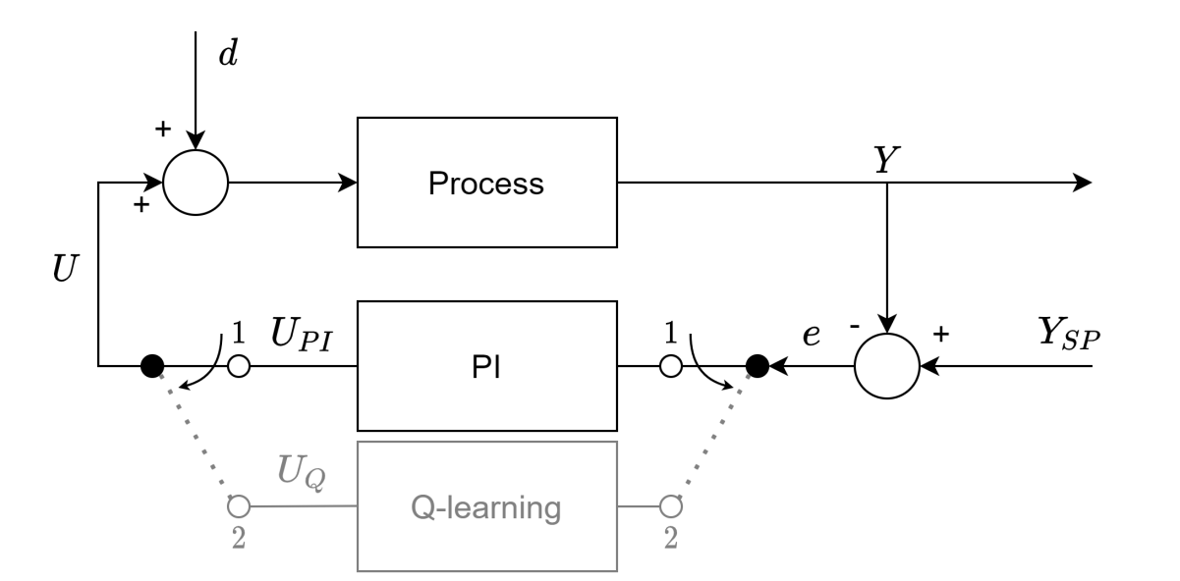

Fig. 1. Schematic diagram of the considered closed-loop control system with the existing PI controller. After bumpless switching to the Q-learning algorithm, the self-improving properties should provide improvement in the control performance by online learning via interaction with a Process.

It is assumed that the existing PI controller is pre-tuned, with known tuning parameters and provides acceptable but too sluggish control performance. Because it is also assumed that any process model is unknown, the Q-learning controller must initially preserve the control performance that is very similar to the performance of the existing PI controller. While controlling the process, during the exploration phase, the Q-learning controller is expected to progressively improve its performance and achieve the desired target closed-loop behavior by learning directly from interaction with the dynamic process.
The only available information about the existing close-loop system is the PI controller tuning, which should be used to initialize the Q-learning properly to ensure smooth switching between both controllers. Additionally, it is assumed that the Q-learning controller has a predefined and discretized state space and a set of available actions. Both sets should be determined based only on the very general information about the operating conditions of the closed-loop system.
The concept presented in this work is based on the Q2d approach described in details in [PAPIER W Applied Soft Computing] in which it was shown that the Q2d controller provides satisfying improvement in the control performance for processes without time delay. Its performance was validated both by simulation and experimentally in the application to the electric drive system. In this section, only the most important background of Q2d approach is presented to allow the reader to follow the concept proposed in this paper.

- Short introduction to Q2d controller design
Q2d approach is dedicated to control the single-input single-output (SISO) dynamic process with control signal U(t), process output Y(t), desired setpoint Y_{SP}(t) and control error e(t)=Y_{SP}(t) – Y(t). The control objective is to keep the control error within the predefined range (-precision, precision). The desired closed-loop behavior is defined by the first order trajectory:
$F\left(e,\dot{e}\right)=\dot{e}+\left(1/T_{e}\right)e=0$ (2)
where T_{e} > 0 is desired closed-loop time constant and ė is the control error derivative.
This formulation of the closed-loop trajectory provides an intuitive link to the existing PI controller represented as:
$$ΔU_{PI}\left(t\right)=K_{PI}T_{s}\left(\dot{e}\left(t\right)+\frac{1}{T_{I}}e\left(t\right)\right) (4)$$
where K_{PI} is the proportional gain, T_{I} is the integral time and T_{s} is sampling time. Based on that the control output for Q2d controller is:

$$ΔU_{Q}\left(t\right)={K_{Q}T_{s}∙s=K}_{Q}T_{s}\left(\dot{e}\left(t\right)+\frac{1}{T_{e}}e\left(t\right)\right) (5)$$
and after assuming K_{Q} = K_{PI} the similarities between formula (4) and (5) become clear.
In Q2d approach, the states are created by merging control error and its time derivative into a single state based on target trajectory:
$s=\dot{e}+\frac{1}{T_{e}}e$ (6)
This state formulation has a clear physical interpretation because s quantifies the deviation from desired first-order trajectory (2). When s=0, the error evolves according to $\dot{e}= -(1/T_{e})e$ trajectory which means that the closed-loop system accurately follows the target trajectory. Positive values s>0 show that the error is decreasing too slow and when s<0, the situation is opposite. State vector S accommodates both negative and positive values and represents the discrete state space as:
$S=\left[-s_{N-1}, -s_{N-2}, …,-s_{1}, s_{1}, …, s_{N-1}\right]$ (7)

where N is total number of states, typically even number to include symmetrical states on both sides of s=0.
To provide efficient scaling and desired precision application, in Q2d approach it is proposed to apply the exponential distribution of control error, which ensures that the accuracy of the state distinction increases as the absolute value of the control error decreases. Based on this approach, two vectors are generated: one for the discretized control error and one for its discretized time derivative. Both are generated assuming maximal possible error value e_{max} and the precision determining accuracy of reaching the goal state. Next, based on these two vectors, the vector representing the boundaries of the states intervals S in the form (7) is computed. Finally, the vector of the mean values of two neighboring state boundaries is generated and this vector is directly used for generating the vector of the accessible Q2d controller actions A:

$A=[-a_{N}, -a_{N-1}, …, -a_{2}, a_{1}=0, a_{2}, …,a_{N}]$ (8)

where a_{i} = K_{Q}·T_{s}·$s_{i}^{m}$, which ensures that these actions are identical to those that the PI controller would take in the same state computed by Eq. (4), with the accuracy of discretization.
By assumption, in Q2d approach the reference trajectory defined by T_{e} differs significantly from the closed-loop trajectory ensured by the existing PI controller with its integral time T_{I}. This fact requires application of the projection function that ensures the simple Q2d initialization providing bumpless switching between the existing PI controller and the designed Q2d controller. For this purpose, it is assumed that K_{PI} = K_{Q} and combining Eqs. (4) and (5) leads to:

$ΔU_{Q}={K_{Q}T}_{s}\left(\dot{e}+\frac{1}{T_{e}}e\right)- e \left(\frac{1}{T_{e}}-\frac{1}{T_{I}}\right)$, (9)

which finally allows to define Q2d control law modified by the projection function:

${ΔU}_{Q}= a-e\left(1/T_{e}-1/T_{I}\right)$. (10)

where a is the action selected for current state s. From practical reasons, the control signal must be also saturated as $U_{Q}ϵ[U_{min},U_{max}]$.
Such an approach to generating state and action vectors results in the 2-dimentional Q-matrix (2N-1)x(2N-1) that stores the correlation between the current systems state and the corresponding so-far optimal action. At the same time, due to similarities of the discretized state-action space to the PI controller, the initialization of Q2d controller is very easy. Adjusting Q matrix as the identity one ensures that after switching between the existing PI controller and its substitute (Q2d controller), the switching is practically bumpless because Q2d controller performs practically the same as the existing PI controller.
To ensure learning abilities of Q2d controller, its exploration/exploitation problem is addressed using the modified ε-greedy method [papier z Applied Soft computing]. In conventional Q-learning approach, the exploration phase requires an unrestricted range of randomized actions. However, this is unacceptable in industrial closed-loop systems where learning must be carried out during normal operation and thus the closed loop system cannot be disturbed by wide variety of randomized action. In Q2d approach the range of drawing actions is limited by introducing the parameter RD that directly limits the range of draws around the optimal action represented by the highest value in the Q-matrix. This approach reduces the intentional disturbances intentionally applied to the closed loop system only by drawing actions whose values significantly differ from the current optimal action.
In addition, the action randomness was reduced further by enforcing the same sign action as highest Q-value one. This preventing changing $ΔU$ sign near goal state.

3. Modification of Q2d approach for processes with dead time

Q2d was validated by simulation and experimentally with the assumption that the control process has no dead time in its dynamics. In industrial automation such an assumption is not realistic because many industrial processes are characterized by the presence of the dead time in their dynamics. In this paper it is proposed how to extend the Q2d approach to the processes with a significant dead time.

3.1. Difficulties with process dead time

The presence of dead time T₀ in the process dynamics poses a fundamental challenge for Q2d controller because the basic Q-learning policy (1) assumes that the direct effect of action a_{t} is observable in the next state s_{t+1}, When dead time exceeds the single sampling interval (T₀ >> T_{s}), the control action ΔU_{Q} affects the measured process output at time (t + T₀). This fact provides a significant problem with reward policy because in the presence of process dead time, Q2d controller rewards the actions whose effect on the process output will be seen in the future after dead time T₀. Without proper modifications in the reward policy, Q2d controller is unable to ensure proper update of the state-action pairs which leads to poor or even failed learning abilities. Such a modification is proposed in the next section.

3.2. Dead time compensation for Q2d approach

For Q2d approach, the major challenge with the presence of the process dead time T₀. is to ensure that Q-value update policy can reward the correlated state-action pairs because the effect of the action a_{t} taken at time t becomes observable at time (t + T₀).
To deal with this difficulty, at this stage it is assumed the dead time T₀ is known. Then it is proposed to use the FIFO buffers that store state-action pairs and thus delay the Q-value updates until the effect of the applied action becomes observable. The buffer size is determined based on the knowledge of dead time:
$N_{buffer}=trunc\left(\frac{T_{0}}{T_{s}}\right)$ (11)
Based in eq.11 the policy of Q-learning update can be modified:
$Q\left(s_{t-N_{buffer}},a_{t-N_{buffer}}\right)⃪Q_{p}\left(s_{t-N_{buffer}},a_{t-N_{buffer}}\right)+α\left[R+γ*\max_{a}⁡Q\left(s_{t+1},a_{t+1}\right)-Q_{p}\left(s_{t-N_{buffer}},a_{t-N_{buffer}}\right)\right]$ (12)
This assures that proper state/action pair will be rewarded when action consequences are visible in plant output.
Reward strategy:
The choice of reward function significantly influencing Q-learning convergence and the learning process. Reward strategy that provides positive reward only at the goal state was employed:
$R= \left\{\begin{aligned}1 if s_{t-N_{buffer}}=s_{goal} and a_{t-N_{buffer}}=a_{goal} \\ 0 otherwise\end{aligned}\right.$ (13)
Where s_{goal} is the discrete state closest to s=0 and a_{goal} is the zero control increment action.
This reward design ensures that:
- Direct reward at goal: The Q(s_{goal}, a_{goal}) will always be the highest value in whole Q-table, non-other state-action pair can achieve the max value of goal pair.
- Bootstrapped learning: All other Q-values are learned through the bootstrap term γ max_{a} Q(s_{t+1}, a_{t+1}) in (12). States that frequently transition to states with high Q-values will themselves acquire high Q-values, propagating the goal value backwards through the state space.
- Goal state preference: Because only the goal state provide direct reward, the controller leans to drive the system toward s=0 (the target trajectory) rather than lingering in off-trajectory states.
- Zero action enforcement: By rewarding only when a=a_{goal}, we prevent the controller from selecting non-zero action in the goal state, which would unnecessarily disturb the steady-state operation.
- As learning progress and the goal state is visited repeatably. States further from goal acquire lower Q-values based on the expected cumulative discounted reward for following the optimal trajectory towards the goal. This creates the gradient in the Q-matrix that guides the controller toward the target trajectory.

Validation and results:
Validation of the proposed Q2d controller with projection function and dead time compensation was done through simulation studies on two benchmarks models representing common industrial dynamics. All experiments were conducted in MATLAB/Simulink environment with sampling time T_{s} = 0.1s.
Model 1 – first order inertia:
$G_{1}\left(s\right)=\frac{k}{Ts+1}e^{-T_{0}s}=\frac{1}{5s+1}e^{-T_{0}s}$ (26)
This represents simple thermal processes, flow control or level processes where dominant dynamics are characterized by a single time constant.
Dead time scenario
Three dead-time values scenarios were investigated:
- T₀ = 0.5s: baseline case without deadtime
- T₀ = 2s: Moderate deadtime
- T₀ = 4s: Significant deadtime near half of time constant
For each three compensation strategies were performed:
- Udercompensation: $T_{0, controller}=0.8 T_{0}$
- Perfect compensation: $T_{0, controller}=T_{0}$
- Overcompensation $T_{0, controller}=1.2 T_{0}$
PI controller tuning in all experiments were set to Siemens PLC default tunings:
- K_{PI} = 1
- T_{I} = 20
Q2d parameters were set as follows:
Parameter | Symbol | Value
Controller gain | K_{Q} | 1 (=KPI)
Goal trajectory time constant | T_{e} | 5s
PI Integral Time | T_{I} | 20 s
Learning rate | $$α$$ | 0.1
Discount factor | $$γ$$ | 0.99
Exploration rate | $$ϵ$$ | 0.3
Random deviation | RD | 3
Precision | precision | 0.1%
Number of states | N | 50
Sampling time | T_{s} | 0.1
Control limits | [U_{min}, U_{max}] | [0%, 100%]
Set point | Y_{SP} | 50%

Every test scenario was performed on load disturbance randomly drawn from normal distribution with $σ_{d}=\frac{0.5}{3}$(three sigma rule) and $μ=0$. Time of disturbance was also randomize using normal distribution $σ_{N}=150$and $μ=3000$. This means that not every disturbance will be regulated before new will be generated. Using normal distribution is way to mimic most common disturbance appearance in real industrial systems. To compare results all experiments were conducted on the same random number generator to assure same learning environment.
After every 100 epoch of learning (100 generated disturbances) the verification experiment was performed when $ϵ=0$ to allow comparation without random action exploration. At the beginning of each experiment Y_{SP} was changed to 20% and controller was put in manual mode to set process output Y to 20%. Three phases of experiment were performed:
- Y_{SP} change to 50%
- Generating disturbance d=0.3
This guaranty that every experiment can be compared to each other and following metrics could be computed:
- Integral Absolute Error (IAE): $\int_{0}^{T}{\left|e\left(t\right)\right|dt}$
- Maximum Overshoot: $\max_{t}\left|Y\left(t\right)-Y_{SP}\right|$
- Maximum control Increment: $\max_{t}{|ΔU_{Q}\left(t\right)|}$

A.
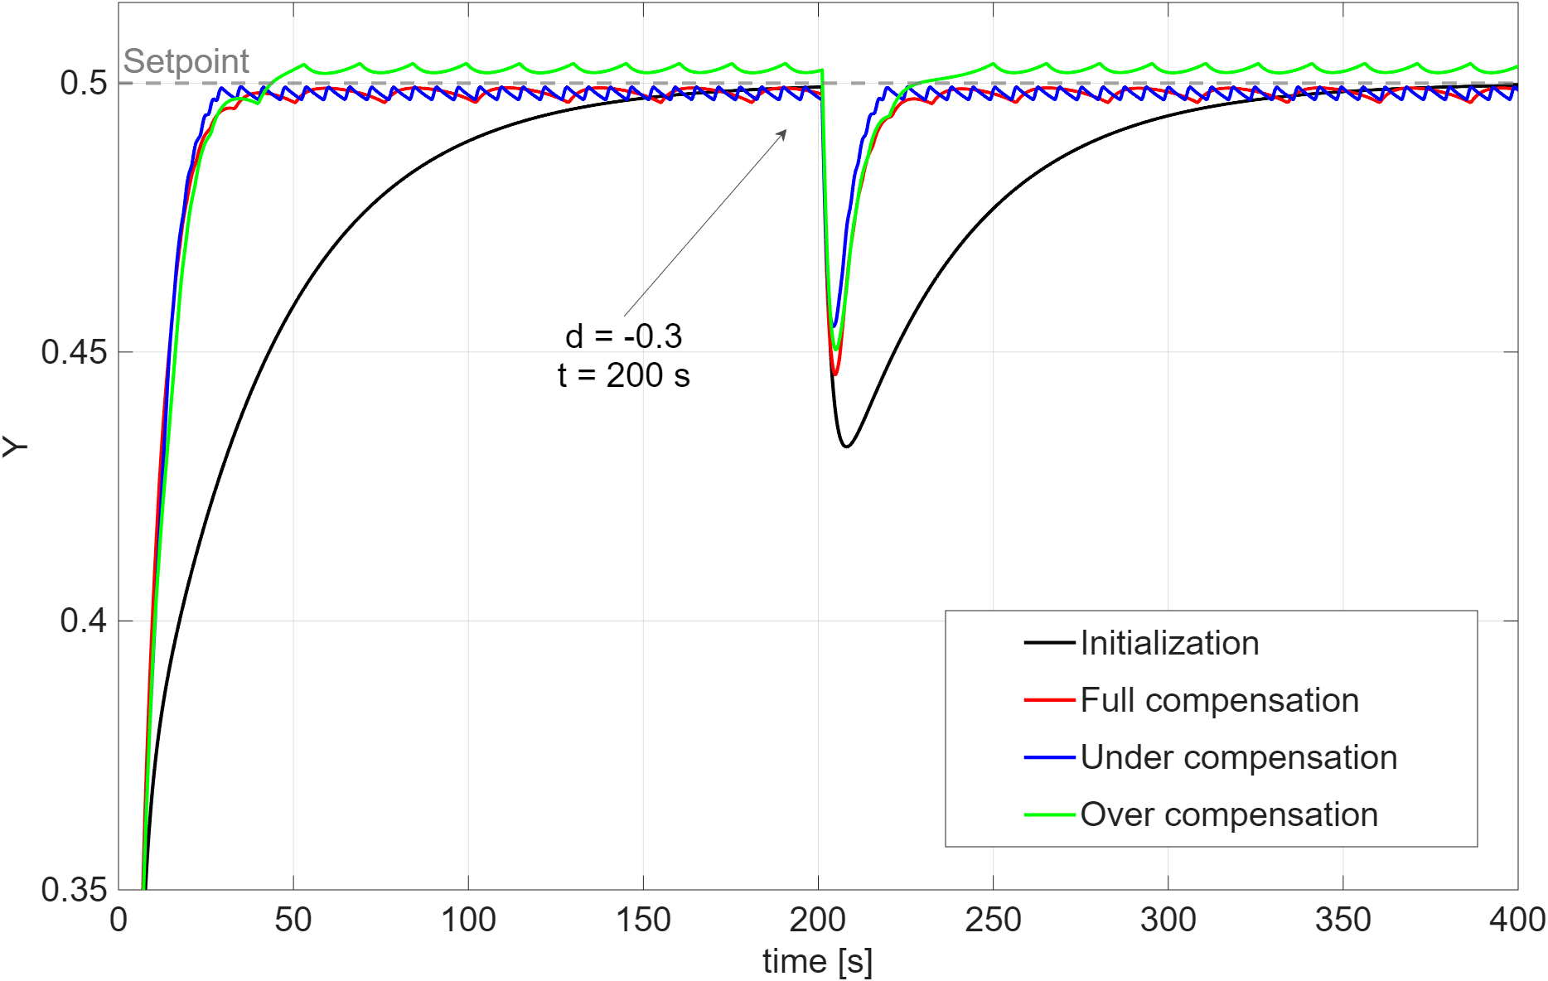B.
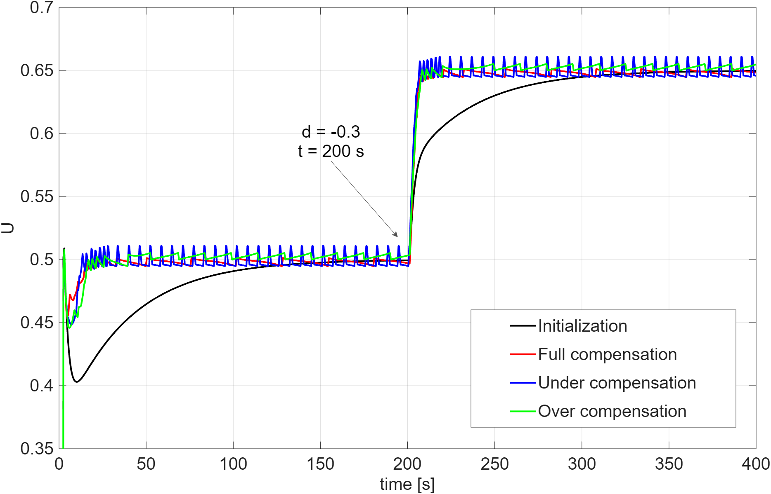
Fig. 2. Improved performance after 3000 learning epochs for Y_{SP} change and disturbance reduction when T0=0.5. “Initialization” represents the performance of the Q2d method after initialization based on the existing PI tunings, without learning. Next, the learning results are shown with different dead-time compensation strategies. Diagram (A) represents variations of the controlled variable Y while diagram (B) variations of the manipulating variable U.
A.
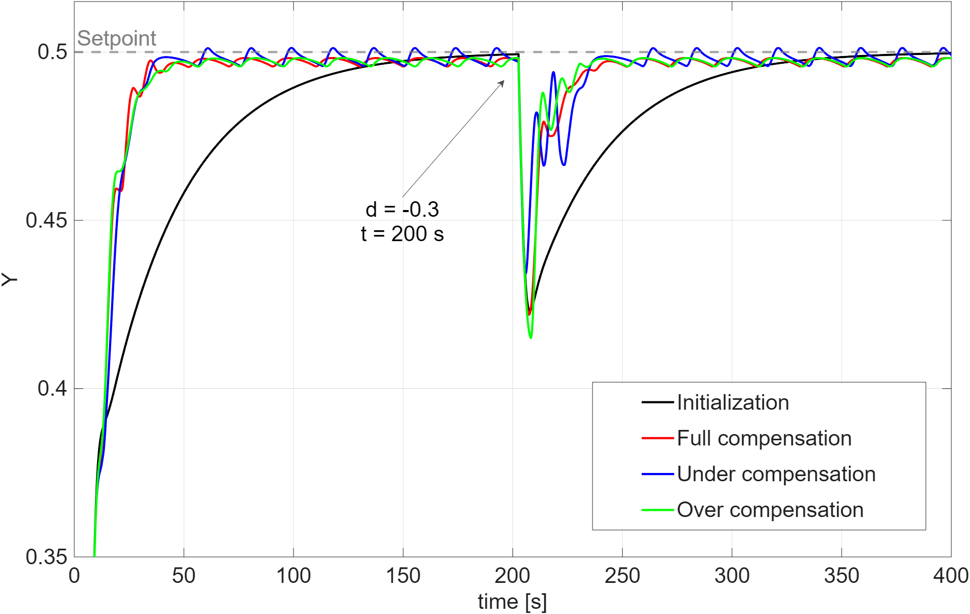B.
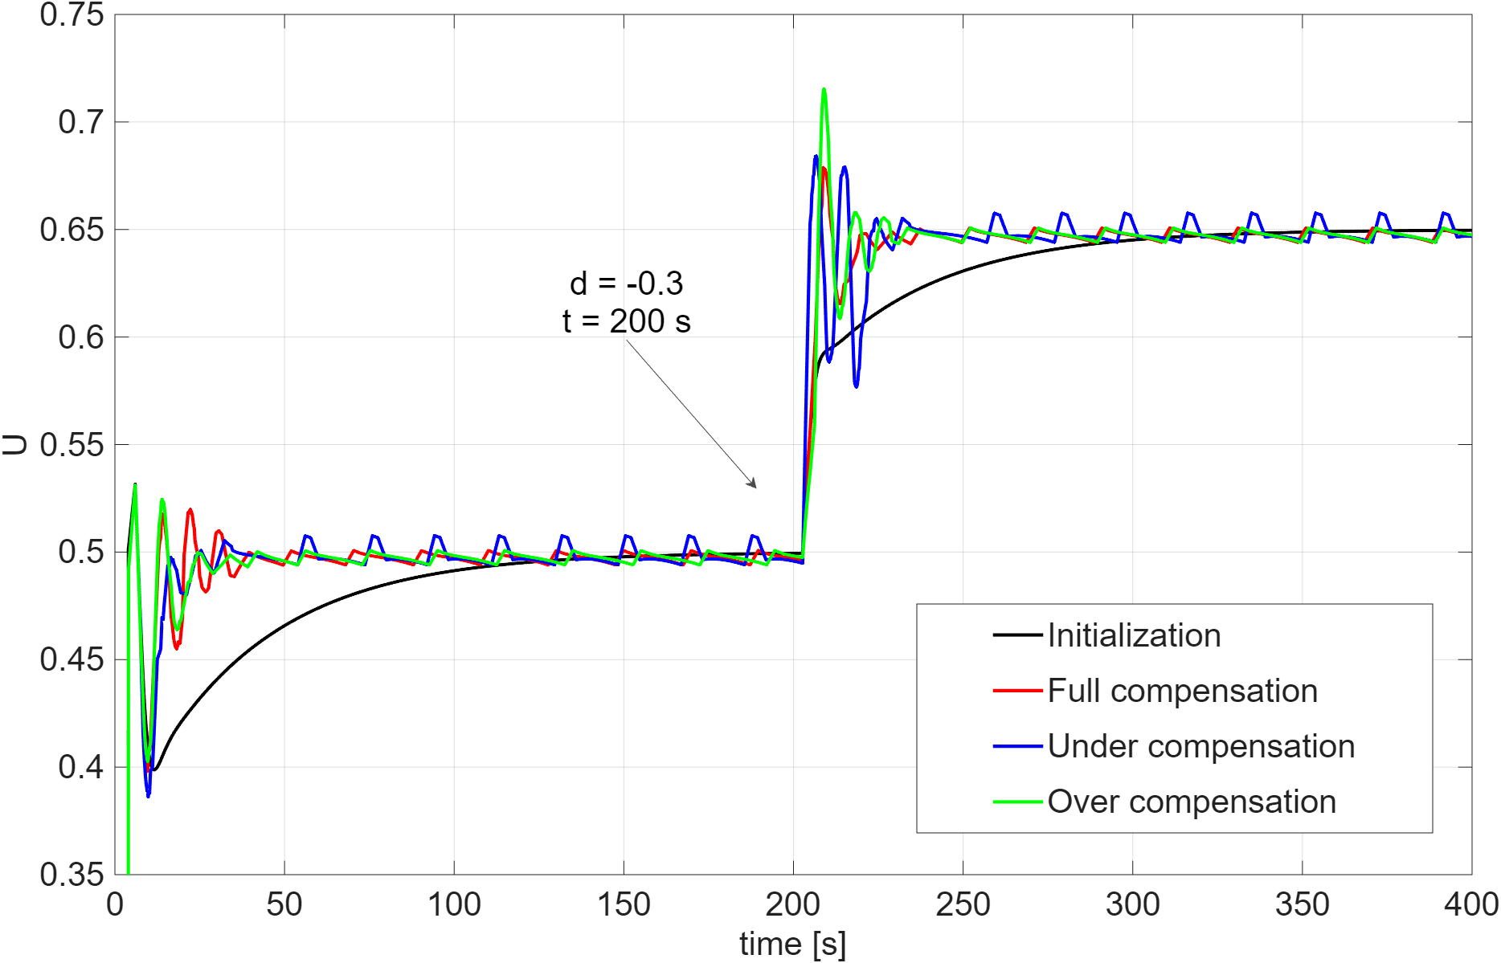
Fig. 3. Improved performance after 3000 learning epochs for Y_{SP} change and disturbance reduction when T0=2. “Initialization” represents the performance of the Q2d method after initialization based on the existing PI tunings, without learning. Next, the learning results are shown with different dead-time compensation strategies. Diagram (A) represents variations of the controlled variable Y while diagram (B) variations of the manipulating variable U.
A.
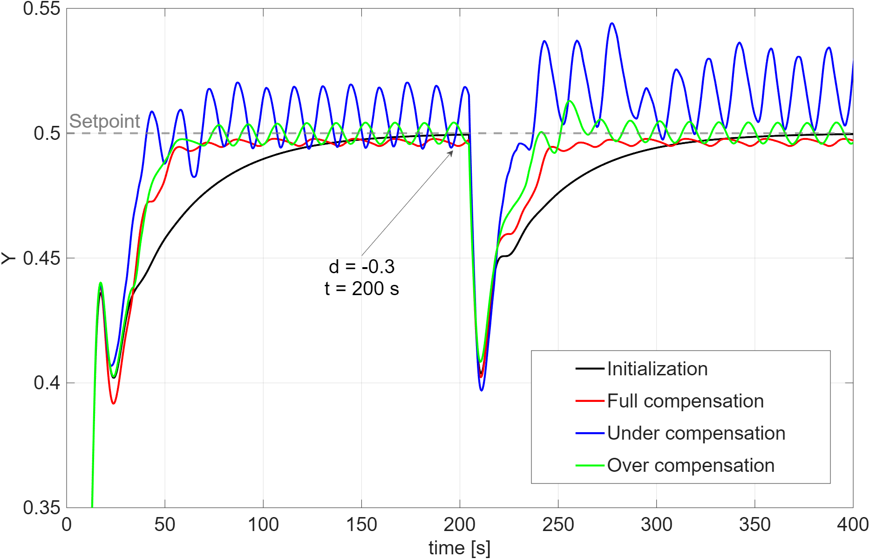B.
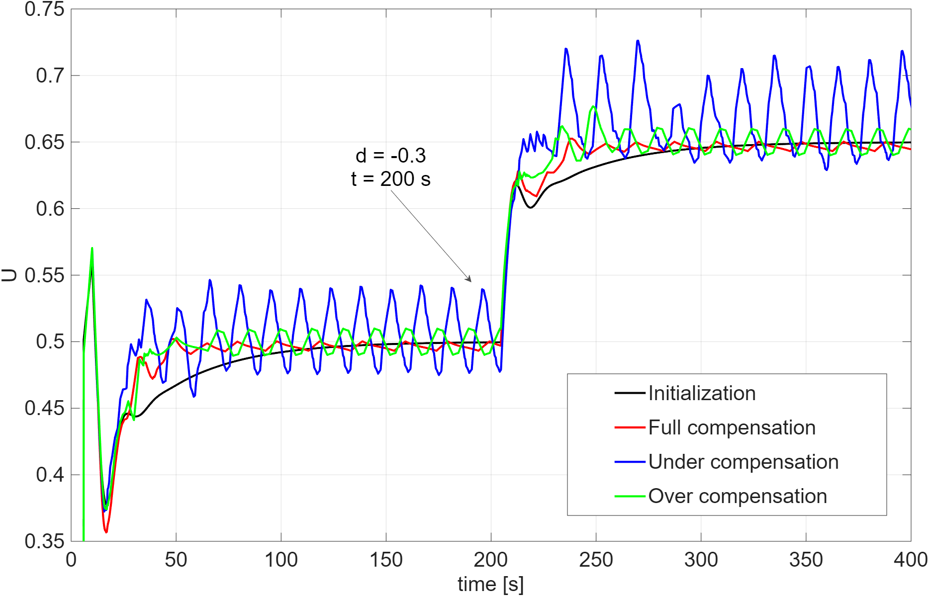
Fig. 4. Improved performance after 3000 learning epochs for Y_{SP} change and disturbance reduction when T0=4. “Initialization” represents the performance of the Q2d method after initialization based on the existing PI tunings, without learning. Next, the learning results are shown with different dead-time compensation strategies. Diagram (A) represents variations of the controlled variable Y while diagram (B) variations of the manipulating variable U.
Table 1 summarizes the quantitative performance indicators obtained after 3000 learning epochs for three different dead time values T₀=0.5, T₀=2 and T₀=4, considering set-point (Y_{SP}) change and disturbance rejection. For each case, the results are compared for the initialization stage and for three dead time compensation strategies: full compensation, under compensation and overcompensation. The corresponding time domain responses of the controller variable Y and the manipulating variable U are illustrated in Fig 2-4.
For the smallest dead time, T₀=0.5, all compensation strategies lead to a significant improvement over the initialization. However, full compensation consistently provides the most balanced performance. In the case of Y_{SP} changes, it achieves the lowest IAE (268.5) among all learning-based configurations while maintaining negligible overshoot and control effort comparable to the initialization. Although under-compensation yields a slightly lower IAE for disturbance rejection, this improvement is accompanied by more pronounced oscillations in the manipulating variable, as visible in Fig. 2(B). Full compensation, in contrast, achieves a strong reduction in disturbance-related IAE (83.6) while preserving smoother control action, indicating a better trade-off between performance improvement and control aggressiveness.
For moderate dead time, T₀=2, the advantages of full compensation become more apparent. While all learning-based strategies reduce the IAE for Y_{SP} changes to a similar level, full compensation maintains negligible overshoot and moderate control effort. In disturbance rejection, under-compensation attains the lowest IAE, however, this is achieved at the cost of increased control signal oscillations and higher values of maximum control increment. Over-compensation further amplifies these effects, leading to increased overshoot. Full compensation offers more consistent behavior, providing substantial improvement over the initialization while avoiding excessive oscillations, as confirmed by the smoother trajectories in Fig. 3.
For the largest dead time, T0=4, the sensitivity to compensation accuracy becomes critical. Under-compensation leads to a significant degradation of control performance, with IAE exceedingly even the initialization value, which indicates improper credit assignment during learning. Over-compensation improves disturbance-related IAE but introduces noticeable oscillatory behavior in both the controlled and manipulating variables. Full compensation, although not achieving the minimum IAE in every metric, delivers the most stable and predictable response, maintaining moderate overshoot and avoiding the pronounced oscillations observed for the mismatched compensation strategies. This behavior is clearly illustrated in Fig. 4, where full compensation provides the smoothest closed-loop response among the learned controllers.
Overall, the results demonstrate that full dead-time compensation yields the most robust and reliable learning performance across all investigated dead-time scenarios, while slightly over or underestimated dead-time values still allow controller to learn proper trajectory.

Table 1.
Scenario | Metric | T0=0,5
Scenario | Metric | Initialization | Full comp. | Under comp. | Over comp.
SP change | IAE | 634,9 | 268,5 | 271,5 | 294,8
SP change | Max u | 30,2 | 29,2 | 29,2 | 29,2
SP change | Max overshoot | 0,0 | 0,0 | 0,0 | 0,4
Disturbance | IAE | 301,1 | 83,6 | 71,3 | 89,3
Disturbance | Max u | 0,3 | 0,4 | 0,4 | 0,4
Disturbance | Max overshoot | 6,8 | 5,4 | 4,5 | 5,0
 |  | T0=2
SP change | IAE | 635,2 | 340,3 | 344,1 | 343,0
SP change | Max u | 30,2 | 29,2 | 29,2 | 29,2
SP change | Max overshoot | 0,0 | 0,0 | 0,1 | 0,0
Disturbance | IAE | 301,0 | 135,4 | 113,6 | 125,6
Disturbance | Max u | 0,3 | 0,5 | 0,8 | 0,8
Disturbance | Max overshoot | 7,7 | 7,8 | 6,6 | 8,5
 |  | T0=4
SP change | IAE | 635,6 | 526,7 | 547,9 | 490,4
SP change | Max u | 30,2 | 29,2 | 29,2 | 29,2
SP change | Max overshoot | 0,0 | 0,0 | 2,0 | 0,4
Disturbance | IAE | 300,8 | 237,5 | 437,2 | 198,7
Disturbance | Max u | 0,3 | 0,3 | 0,3 | 0,3
Disturbance | Max overshoot | 9,6 | 9,8 | 10,3 | 9,2

CONCLUSIONS:
Based on the general Q-learning framework, this paper presents an extension of the Q2d control algorithm for processes with significant dead time. The primary contribution consists in modifying the standard Q-learning credit assignment mechanism by introducing delayed Q-value updates using FIFO buffers synchronized with the process dead time. This modification enables correct association between executed control actions and their delayed effects on the process output, which is a fundamental requirement for successful learning in systems with transport delay.
The proposed solution preserves all essential advantages of the original Q2d approach. In particular, the controller does not require knowledge of the mathematical model of the controlled process, and the control objective is defined through a reference trajectory formulated in terms of the control error and its time derivative. The projection-based initialization ensures practically bumpless switching from an existing PI controller, using only the PI tuning parameters and sampling time. As a result, the extended Q2d method fulfills the assumptions of a self-improving controller also in the presence of dead time.
Simulation results confirm that the proposed delayed update mechanism enables effective online learning for processes characterized by small, moderate, and significant dead time. For all investigated scenarios, the Q2d controller initialized from PI tuning preserves the initial closed-loop performance both for set-point tracking and disturbance rejection. After switching to exploration mode, the controller progressively improves performance as quantified by the reduction of the integral absolute error and, in most cases, by reduced overshoot and improved disturbance attenuation. The results also demonstrate that the effectiveness of learning strongly depends on the relationship between the actual plant dead time and the dead-time value assumed by the controller for credit assignment.
For small and moderate dead times, the learning process leads to substantial performance improvements compared to the initialization stage. For larger dead times, improvement remains possible but becomes more sensitive to the adopted compensation strategy. In particular, under-compensation may lead to performance degradation in disturbance rejection, while over-compensation may improve certain performance indices at the expense of increased oscillatory behavior. These observations highlight the importance of appropriate dead-time estimation in practical implementations.
An important advantage of the proposed method is that learning is performed during normal closed-loop operation and does not require dedicated excitation signals. The controller can learn from naturally occurring disturbances, which makes the approach more suitable for industrial environments where intentional perturbation of the process is often unacceptable. At the same time, the restriction of the exploration range through the RD parameter ensures that online learning does not introduce excessive or unsafe control actions.
Apart from the demonstrated advantages, several limitations remain and require further investigation. First, the proposed solution assumes that the process dead time is known with reasonable accuracy. Although the influence of under- and over-compensation has been analyzed, a systematic method for online dead-time identification or adaptive dead-time estimation would further improve robustness. Second, the learning performance depends on the tuning of Q-learning parameters such as the learning rate, discount factor, exploration rate, and exploration range limitation. Practical guidelines for systematic tuning in industrial environments should be developed. Third, the validation was carried out for a first-order process model; extension to higher-order, integrating, or strongly nonlinear processes requires additional investigation.
Despite these limitations, the obtained results demonstrate that the Q2d approach can be successfully extended to processes with dead time while preserving its computational efficiency, model-free character, and bumpless initialization from existing PI controllers. The proposed modification enables practical application of reinforcement learning-based control in a broader class of industrial processes where time delay is unavoidable.

Bibliografia
B. Jang, M. K. (2019). Q-learning algorithms: a comprehensive classification and applications. IEEE Access 7, pp. 133653-133667.

